User Manual
Toiletries Case
~~Created By~~
PROJECT TEAM 3 ©

User Manual
Toiletries Case

Table of Contents
Assembly ~~~~~~~~~~~~~~~~~~~~~~~~~~~~~~~~~~~~~~~~ 3
Regular Use ~~~~~~~~~~~~~~~~~~~~~~~~~~~~~~~~~~~~~~ 4
Maintenance ~~~~~~~~~~~~~~~~~~~~~~~~~~~~~~~~~~~~~~ 5
Warranty Information ~~~~~~~~~~~~~~~~~~~~~~~~~~~~~~~~~ 6
FAQ ~~~~~~~~~~~~~~~~~~~~~~~~~~~~~~~~~~~~~~~~~~~~ 7
Service Center ~~~~~~~~~~~~~~~~~~~~~~~~~~~~~~~~~~~~~ 8

Assembly
Toiletries Case

The Toiletries Case is bought and sold as one whole item and does not require further assembly. The Toiletries Case is comprised of 3 separate parts.
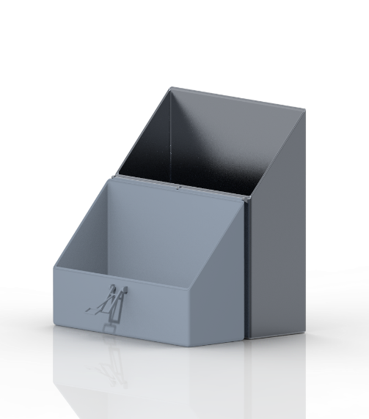
The top of the Toiletries Case (pictured light grey).
The bottom of the Toiletries Case (pictured dark grey).

The latch (pictured green).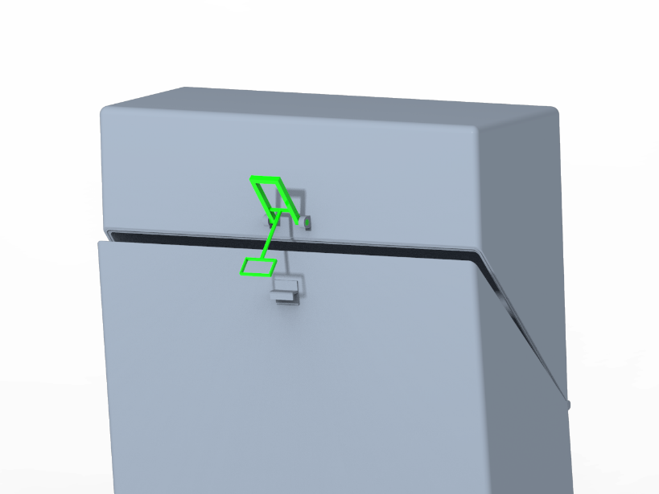
Regular Use
Toiletries Case

The Toiletries Case is used to store bathroom items such as toothbrushes, razors, floss, and more items (not included with purchase of the Toiletries Case).
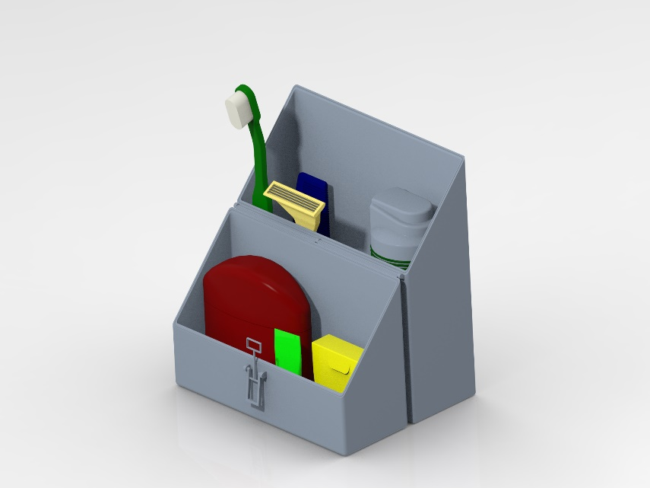
The Toiletries Case is 7.3" tall, 5.3" wide, and 1.8" thick, making it capable of fitting in the average pocket. The latch is used to close and seal the opening of the Toiletries Case, making an airtight fit that traps water.
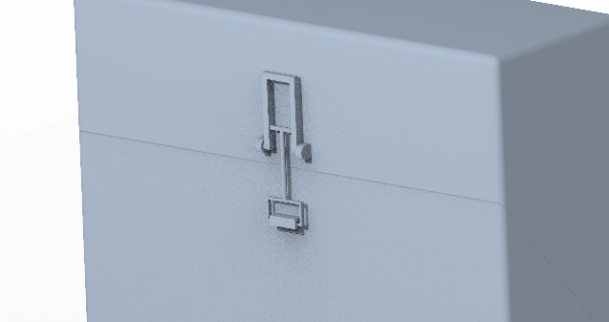
Maintenance
Toiletries Case

The Toiletries Case may collect grime over time as the water is trapped inside.
We recommend that the Toiletries Case be cleaned once every two weeks to avoid a buildup of unwanted filth inside.
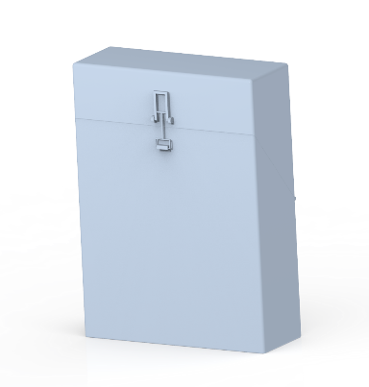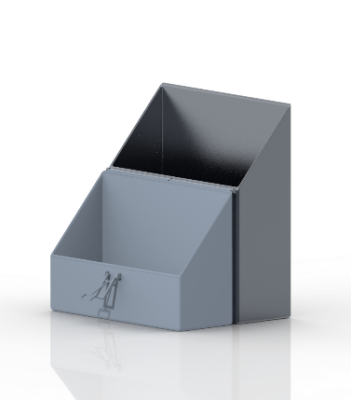
To clean, open the Toiletries Case and remove all items from inside. Fill the Toiletries Case with water and disinfectant soap of your choice. Close the Toiletries Case and secure the latch to trap the disinfectant soap and water inside. Once secured, shake the Toiletries Case vigorously for 30 seconds to 60 seconds depending on how dirty the Toiletries Case is. When done, open the Toiletries Case a dump out the disinfectant soap and water. Appropriately dry the Toiletries Case and leave open to allow for the Toiletries Case to fully air dry. After 30 minutes, the Toiletries Case is back to full health.
Warranty Information
Toiletries Case

The Toiletries Case comes with a 2-year warranty that guarantees a replacement to be issued in the event that the Toiletries Case breaks due to a manufacturing error, such as a faulty print resulting in a fault.
The Toiletries Case can be replaced free of charge if the bought Toiletries Case has a noticeable error, such as a crack or splinter upon receiving.
If the Toiletries Case breaks due to user error, Project Team 3 is not required to replace or refund the Toiletries Case.

(Project Team 3 is not responsible for any injuries caused by using the Toiletries Case.)

FAQ (Frequently Asked Questions)
Toiletries Case

Question 1:
“Is the Toiletries Case waterproof?”
Answer:
Yes, the Toiletries Case is designed to latch in a way that creates an air tight seal.
Question 2:
“How easy is it to travel with the Toiletries Case?”
Answer:
The Toiletries Case is designed to fit inside of the average pocket size, making it very easy and practical to travel with.
Question 3:
“Can all of my items fit inside of the Toiletries case?”
Answer:
Yes, the Toiletries Case has been designed to hold multiple standard sized items that you would pack in any other toiletries case.
Service Center
Toiletries Case

Project Team 3 is based at the University of North Carolina at Charlotte.
Address
9201 University City Blvd, Charlotte, NC, 28223
Website
https://webpages.charlotte.edu/tzalevsk/1202toiletries/index.html
Phone Number
704-PRO-JECT

Operator Contact
Carter Meadows  cmeado11@uncc.edu | Thomas Zalevskiy  tzalevsk@uncc.edu
Joey Porter
jporte56@uncc.edu

